**A PROJECT REPORT ON**



**EVENT MANAGEMENT SYSTEM**

**DEVELOPED FOR**

**PAARSH INOFOTECH PVT LTD, NASIK**

**BY**

**AKASH ANANDA GAWANDE**

**FOR THE PARTIAL FULFILLMENT OF THE DEGREE MASTER IN COMPUTER APPLICATION**

**SUBMITTED TO**

**KCES’s INSTITUTE OF MANAGEMENT AND RESEARCH, JALGAON**

**AFFILIATED TO**

**KBC NORTH MAHARASHTRA UNIVERSITY, JALGAON**

**2023-2024**



C e r t i f i c a t e

To whomsoever it may concern

This is to certify that Mr. / Ms. Akash Ananada Gawande a student of MCA (Master of Computer Application) from Institute of Management and Research, Jalgaon has completed the full time Industrial Training with project titled “Event Management System” at Paarsh Infotech Pvt Ltd, Nasik.

He / She has submitted satisfactory report in partial fulfillment of the requirement for the award of the degree of Master of Computer Application (MCA) during academic year 2023-2024.

(Ms. Sweta Fegade) (Mr. Uday Chatur)

Internal Guide Head, Dept. of MCA

(Dr. Tanuja Fegade) (Dr. B. V. Pawar) Academic Dean & School Director, Director, School of Computer Applications IMR Jalgaon

External Examiner External Examiner

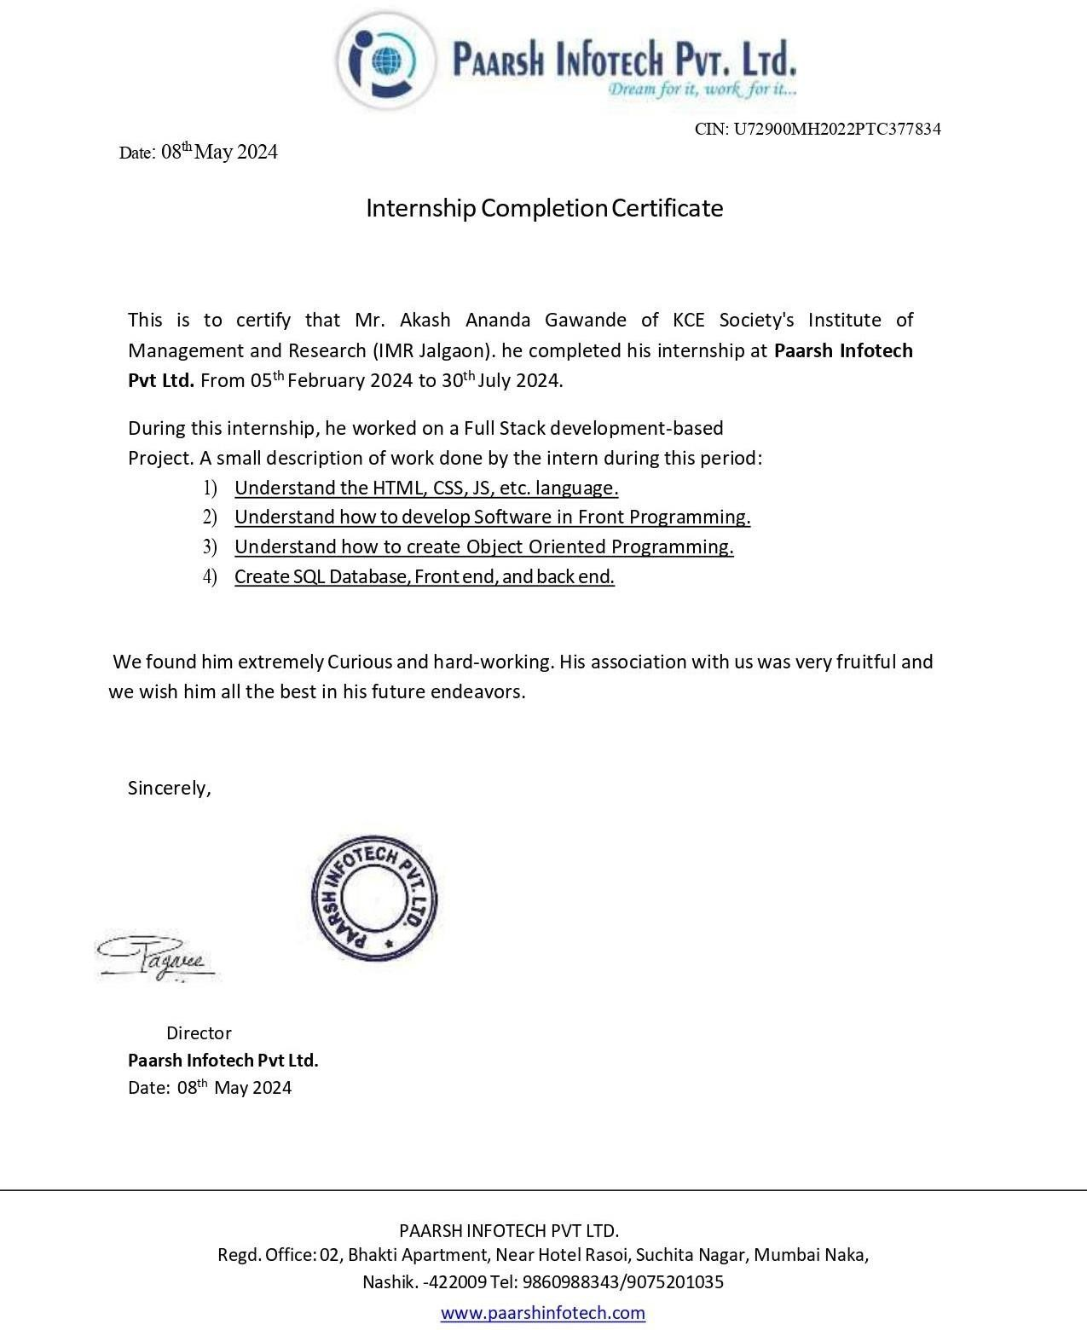

**Acknowledgement**

In the journey of the present project work, numerous personalities, directly or indirectly have extended their help, support and co-operation. In a truly indebted to them I would like to thank **“PAARSH INFOTECH PRIVATE LIMITED”** for giving me an apportunity to work with them.

The satisfaction that accompanies that the successful completion of any task would be incomplete without the mention of people whose ceaseless cooperation made it possible, whose constant guidance and encountered crown all efforts with success. We are grateful to our project guide **Mrs. Shweta Fegade** for the guidance, inspiration and constructive suggestions that helpful to us in the preparation of this project. I would like to thanks to **Mr. Uday Chatur sir** (Head, Dept. of MCA) one or other way has helped me to learn the tricks and concepts of software development.

I would like to thank and express my sincere gratitude to **Dr. Tanuja Fegade** for her valuable guidance and suggestions to finish the project successfully.

I acknowledge most sincerely and respectfully to **prof. B .V. Pawar Sir(Director) Institute of Management and Research** for providing me excellent facilities and guidance I appreciate my colleagues and friends who kindly offered their suggestions, comments and criticism for improvement of this project.

Mr. Akash Ananda Gawande

# ABSTRACT

The Event Management System is a simple PHP/MySQL project that will help an event organizing company or business manage their client event details and market the client event also. This system market also the venue list of the event organizing company's selected possible venue for an event. This event management system allows possible event audiences to register online with the use of the company's website. The audience registration will only serve as a request at first until the system admin or management will reach back to the possible audience to talk or verify the audience registry confirmation for the event and settle the payments if necessary. The system allows also the possible clients to inquire about the client's desired venue in which they possibly place their event. Talking about the management side or admin side of the system, the system has a dynamic list for the venues in which the system users will populate or managed in order to display the venues through their website. The admin or staff will populate the list of events that the company handling along with the details and content or description to display on the website. The event has an option for either the company's clients certain event wants to be published to the website for the possible audience registration or market the event or the company will store only the event details for their reference, For example, the event organizing company's client's event is open for anyone as much as the event audience capacity, the company can help the client's event market online using their website and if the client's event is private or the client has already the list of their audience, the system user can store only the event details for their reference also to populate the event list for the company's report.

# INDEX

|  |  |  |  |
| --- | --- | --- | --- |
| **Sr. No.** | **Topic** | | **Page No.** |
| **1.0** | **Introduction** | |  |
|  | 1.1 | Organization Profile | 9 |
|  | 1.2 | Introduction to Project | 10 |
|  | 1.3 | Aim | 10 |
|  | 1.4 | Existing System | 11 |
|  | 1.5 | Proposed System | 12 |
| **2.0** | **Software Requirement Analysis** | |  |
|  | 2.1 | Need and Motivation | 13 |
|  | 2.2 | Software Development Life Cycle | 13 |
|  | 2.3 | Hardware and Software Specification | 14 |
| **3.0** | **Feasibility study** | |  |
|  | 3.1 | Operational Feasibility | 16 |
|  | 3.2 | Technical Feasibility | 16 |
|  | 3.3 | Economical Feasibility | 17 |
| **4.0** | **System Design** | |  |
|  | 4.1 | General Overview | 18 |
|  | 4.2 | DFD Diagram | 18 |
|  | 4.3 | ER Diagram | 19 |
|  | 4.4 | Sequence Diagram | 21 |
|  | 4.5 | Activity Diagram |  |
|  | 4.6 | Database Design | 25 |
| **5.0** | **System Testing and implementation** | |  |
|  | 5.1 | Unit Testing | 27 |
|  | 5.2 | Integration Testing | 27 |
|  | 5.3 | Software Verification and Validation | 28 |
|  | 5.4 | System Implementation | 30 |
|  | 5.5 | System Maintenance | 37 |
| **6.0** | **Concluding Remarks** | |  |
|  | 6.1 | Scope for future Development | 39 |
|  | 6.2 | Advantages | 40 |
|  | 6.3 | Conclusion | 41 |
| **7.0** | References | | 42 |
| **8.0** | Appendix-Screen Shots | | 43 |

**CHAPTER 1: INTRODUCTION**

## Organization Profile

**Name :** PAARSH INOFOTECH PVT LTD, NASIK

**Website:** [www.paarshinfotech.com](http://www.paarshinfotech.com/)

**Mail** : [info@paarshinfotech.com](mailto:info@paarshinfotech.com)

**Mobile Number :** +91 9860988343

### About Us

At **Paarsh InfoTech Pvt Ltd**, we provide best quality products & Services that you recommend to your friends and family. We have built an extra ordinary SOP's that helps people and businesses communicate more reliably, effectively and securely. We put people first, do the right thing and succeed together.

Join us on this exhilarating journey where technology is not just a tool but a force for positive change, empowering individuals and securing our digital landscape. At PAARSHINOFOTECH, we are not just pioneering technology; we are sculpting a brighter tomorrow. Through dedication and relentless effort, we have grown exponentially. What began as a solitary endeavor has blossomed into a thriving community of over 100 talented individuals We’ve hosted more than 120 seminars, delivered 10 cutting-edge software services, and conducted transformative workshops across diverse industries, social groups, and educational institutions.

**Services Offered by PAARSH** INOFOTECH

PAARSH INOFOTECH focuses on delivering reliable and efficient testing solutions to ensure the quality, functionality, and security of software applications. With a dedicated team of experienced testing professionals and a customer-centric approach, Paarsh InfoTech strives to exceed client expectations and ensure successful software deployments.

**Custom Software Development**: - Paarsh InfoTech offers custom software development services tailored to the specific needs of businesses. We develop robust and scalable software solutions that address unique challenges and automate critical processes.

[**Cyber Security:**](https://mechrocker.tech/services/cyber-security/) **-** Our cyber security services offer tremendous monetary and non-monetary value within your organization. Minimally, an improvement in your security posture keeps **confidential,** classified, and proprietary business materials out of the hands of competitors. Beyond this, the right cyber security policies and protocols boost employee productivity by minimizing computer system downtime while optimizing your website’s uptime.

[**AI & Ml Development:**](https://mechrocker.tech/services/ai-and-ml-development/) **-** Artificial Intelligence and Machine Learning are regarded as one of the most revolutionary technologies of the current times. The global market for AI & ML is predicted to reach a whopping $18 trillion in 2030, up from $93 billion in 2021.

**Cyber Crime Awareness: -** Cybercrime' also known as computer crime involves a wide range of criminal activities that are carried out by using and/or targeting a computer or related system especially illegally to access, transmit or manipulate data. Some cybercriminals conduct cybercrime through the dark web but it is not the case all the time.

## INTRODUCTION TO PROJECT

An **event management system project** also promotes the venue list that the event planning company has chosen as a potential venue for an event. This event management system uses the company’s website to allow potential event attendees to register online.

The system also allows the system users to store the images of the venue and the event banner and other details that may also help the company or client their event or venues.

An event management system project **also** allows potential clients to ask about the client’s preferred venue for their upcoming event. When it comes to the system’s management or admin side, the system has a dynamic list of venues that system users can populate or handle in order to display the venues on their website.

The event management system project admin or staff will fill in the list of events that the company is responsible for, as well as the specifics and content or description that will be displayed on the website. The event management system project in php free download also allows users to save photos of the venue, event banners, and other information that may be useful to the company or client for their event or venue.

This online event management system project in documentation design is straightforward and clean, making it easy for users to learn, use, and navigate.

## AIM

An online Event Management System is a comprehensive digital platform designed to streamline the process of planning, organizing, and executing events. This system is a powerful tool that brings together various aspects of event management under one roof, making it easier for event planners to coordinate and manage events effectively. Event Planning and Management: The system provides tools to manage all aspects of an event, from venue sourcing to vendor management, speaker management, and exhibitor management. It also allows for the creation and management of event websites, registration processes, and marketing campaigns.

1. **Attendee Engagement**: The system offers features for attendee tracking and engagement, such as polling, Q&A, and in-app messaging. This helps in maintaining communication with attendees before, during, and after the event².
2. **Payment Processing**: A seamless ticketing process enhances the overall event experience for attendees and helps boost revenue. The system offers secure checkout, accepts multiple forms of payment, and makes the ticket-buying experience hassle-free.
3. **Event Discovery**: This feature increases the visibility of future events to potential attendees. An event management platform with a search function makes it easy for people looking for events like yours to find you.

**6. Data Integration and Analytics**: The system can integrate event data with other business systems to quickly send leads to sales and marketing and get improved insights. It also stores event data and calculates ROI, understands engagement, manages costs, and improves your event strategy¹.

The Event Management System project you described seems to incorporate many of these features. It aims to provide a user-friendly platform for efficient event planning and management, with a focus on showcasing venues, allowing online registration, and storing relevant event details. The system is designed to be straightforward and clean, ensuring ease of use and navigation for its users.

Please note that the specific features and capabilities of an Event Management System can vary depending on the specific needs of the organization and the software used. It's always a good idea to thoroughly research and compare different platforms to find the one that best suits your needs².

## EXISTING SYSTEM

The current Event Management System is largely manual and fragmented. Event planning and management are often done using various forms, spreadsheets, and standalone tools, making it difficult for event planners to manage and coordinate all aspects of an event effectively.

**Venue Selection and Booking**: The process of selecting and booking venues is often done manually, making it difficult to track available venues and their specific features. There is no centralized system to store and display the images of the venues, event banners, and other relevant details.

**Event Registration**: Event attendees register for events using paper forms or through disparate online platforms. This makes it challenging to manage attendee lists and track registrations effectively.

**Client Communication**: Communication with clients is often done via email or phone calls, making it difficult to manage and track client inquiries and requests efficiently.

**Event Promotion**: Promoting events and venues is done through various channels, making it challenging to manage and coordinate promotional activities effectively.

**Admin and Staff Management**: The admin and staff have to manually manage the list of events and their specifics, which is time-consuming and prone to errors.

**Security and Privacy**: The current system does not guarantee the privacy and security of the data, leading to potential breaches and misuse of information.

**Efficiency and Accuracy**: The manual nature of the current system leads to inefficiencies and inaccuracies in event planning and management. It requires a significant amount of time and resources, making it difficult to manage large-scale events effectively.

To overcome these challenges, there is a need for a comprehensive, integrated, and automated Event Management System. This system would streamline the event planning and management process, making it more efficient, accurate, and user-friendly. It would also ensure the privacy and security of the data, enhancing trust and confidence among the users. The system could potentially leverage advanced technologies such as facial recognition for attendee management, further enhancing its capabilities and effectiveness.

## PROPOSED SYSTEM

The event management system project admin or staff will fill in the list of events that the company is responsible for, as well as the specifics and content or description that will be displayed on the website.

This system market also the venue list of the event organizing company's selected possible venue for an event. This event management system allows possible event audiences to register online with the use of the company's website.

### Why the new system?

With the new system the following activities get more momentum.

1. The actual process of the organization can be modularized into two different independent views
   * Visitor Side
   * Administrators
2. The Visitor Side at any time can view the required information whether it is policies, or customers at the click of a mouse and instance of a second.
3. If planned in an organized manner the customers can be provided an online terminal where they can access the information at their own hands without the basic intervention manually.
4. The customers or policyholder’s reminders can be generated at lightning speed just by query for the specific customers.
5. The information while it is collected can referentially be segregated into their respective databases from single window, saving the time of multiple data entries.
6. The customer’s policy premium payment status can be viewed in a systematized manner by the Agents and cross verify the defaulters.
7. Above all the overall system can at any time provide consistent and reliable information authenticated upon its operations.

### Management Side

**Login Page**

The page where the system users will submit their credentials to access the event management system.

### Home Page

The page where the system user will be redirected by default after logging in.

### Venues Page

The page where the event organizing company's venues are listed and managed.

### Events Page

The page where the company's handled events are listed and managed.

### Venue Book List

The page where the clients book inquiry request online is listed and managed.

### Event Audience List

The page where the event audience or possible audience is listed that submitted their registration request using the website.

### Audience Report

The page that lists the audience of a certain event. The list is organized by events and ready to be printed.

### Venue Report

The page that lists the events in a certain venue. The list is organized by the venue and month, and the list is also ready to be printed.

### Users Page

The page where the event management system users are listed and managed.

### System Settings

The page where can system admin managed the company details to be shown on the website.

### Visitor Side

**Home Page**

The page where the visitor will be redirected by default when browsing the website. This page displays the upcoming events.

### Venues Page

The page where the event organizing company's venues are shown.

### About Page

The page where the event organizing company about content is being shown

## Modules of System

### Event Attendee Panel

An Event Management System is incomplete without an attendee panel that allows them to register for events according to their interests. For the attendee’s login, the default password for each attendee panel will be the same as their usernames. On the first login, the system prompts the attendees to change their password to continue. As soon as the user changes his/her password, the system redirects the user to the event panel. Under the event panel, the attendee will be able to see current events with titles and their respective details. The system will allow attendees to register for any one of the events and asks for confirmation before submitting. As soon as an attendee registers for an event, he/she gets logged out automatically within 2 minutes. And then, the attendee won’t be able to register for the same event again. In summary, these validations help to prevent multiple registrations for a single event from a single account.

**Event Count and Settings** Additionally, the admin panel also consists of viewing the total registration count for each event. These registration counts can be seen from the event section. With this, the admin can have a look at their attendees and non-attendees for the organized events. But, the admin cannot view attendee’s choices as it’s their own privacy. Another main point of events is that the user can add event sessions one at a time. This means an admin cannot create multiple event sessions at the same time. An admin must delete the existing event session before conducting a new one. But, the admin can modify the existing event session anytime.

# CHAPTER 2: SOFTWARE REQUIREMENTS ANALYSIS

## NEEDS AND MOTIVATION

The need for an Event Management System arises from the challenges faced in the current manual and fragmented approach to event management. These challenges include inefficient operations, lack of security and privacy, limited accessibility, and inaccuracies in event planning and management.

The motivation for developing this system is to streamline the event planning and management process, making it more efficient, accurate, and user-friendly. The system aims to provide a centralized platform for showcasing venues, allowing online registration, and storing relevant event details. It also aims to ensure the privacy and security of data, enhancing trust and confidence among users.

## Statement of Problem:

The current manual system of event management is inefficient and prone to errors. It involves a multitude of forms, spreadsheets, and standalone tools, making it challenging for event planners to manage and coordinate all aspects of an event effectively.

Key problems with the existing system include:

* + 1. **Manual Operations**: All operations, including venue selection, event registration, and client communication, are done manually. This makes it difficult to track and manage event details effectively.
    2. **Lack of Security and Privacy**: The current system does not guarantee the privacy and security of data, leading to potential breaches and misuse of information.
    3. **Inefficiency and Inaccuracy**: The manual nature of the current system leads to inefficiencies and inaccuracies in event planning and management. It requires a significant amount of time and resources, making it difficult to manage large-scale events effectively.
    4. **Limited Accessibility**: The existing system does not provide a centralized platform for showcasing venues, allowing online registration, and storing relevant event details. This limits the accessibility and visibility of events.

## Software Development Life Cycle

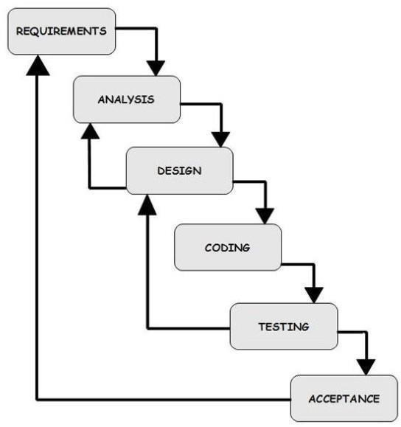

### Waterfall Model

The waterfall model is probably the oldest and the best-known model as far as software development process models is concerned. The role of the waterfall model in software engineering is as important as its role in software testing. Of course, over the years, there are a number of other software process models which have been designed and implemented, but what is true is that a lot of them are based (in some way or the other) on the fundamental principle of the waterfall model.

### Advantages of waterfall model:

1. Simple and easy to understand and use.
2. Easy to manage due to the rigidity of the model each phase has specific deliverables and Review process.
3. Phases are processed and completed one at a time.
4. Works well for smaller projects where requirements are very well understood.

### Disadvantages of waterfall model:

1. Once an application is in the testing stage, it is very difficult to go back and change something that was not well-thought out in the concept stage.
2. No working software is produced until late during the life cycle.
3. High amounts of risk and uncertainty.
4. Not a good model for complex and object-oriented projects.
5. Poor model for long and ongoing projects.
6. Not suitable for the projects where requirements are at a moderate to high risk of changing.

## HARDWARE AND SOFTWARE SPECIFICATIONS

### Hardware Requirements

|  |  |
| --- | --- |
| **Number** | **Description** |
| 1 | PC with 3 GB Ram / Mobile |
| 2 | PC with 1 TB Hard disk. / Mobile with internet connection |
| 3 | Processor: Intel® Core™ i5-6200U CPU @ 2.30GHz |

1. **Software Requirements**

|  |  |  |
| --- | --- | --- |
| **Number** | **Description** | **Type** |
| 1 | Operating System | Windows XP/Windows 7,8.1 or above. |
| 2 | Back-end  Language | JavaScript, PHP |
| 3 | Front-end Language | HTML, CSS, JavaScript. |
| 4 | Database | MYSQL |
| 4 | Web Server: | Tomcat Apache 3.2.3 |
| 6 | Browser | Google Chrome, Mozilla Firefox, and any browser. |

# CHAPTER 3: FEASIBILITY STUDY

A feasibility study is an assessment of the practicality of a project or system. A feasibility study aims to objectively and rationally uncover the strengths and weaknesses of an existing business or proposed venture, opportunities and threats present in the natural environment, the resources required to carry through, and ultimately the prospects for success. In its simplest terms, the two criteria to judge feasibility are cost required and value to be attained. There are 3 parts in feasibility study.

## OPERATIONAL FEASIBILITY

Operational feasibility is the measure of how well a proposed system solves the problems and takes advantage of the opportunities identified during scope definition and how it satisfies the requirements identified in the requirements analysis phase of system development.

The operational feasibility assessment focuses on the degree to which the proposed development projects fits in with the existing business environment and objectives regarding development schedule, delivery date, and corporate culture and existing business processes.

To ensure success, desired operational outcomes must be imparted during design and development. These include such design-dependent parameters as reliability, maintainability, supportability, usability, reducibility, disposability, sustainability, affordability and others. These parameters are required to be considered at the early stages of design if desired operational behaviors are to be realized. A system design and development require appropriate and timely application of engineering and management efforts to meet the previously mentioned parameters. A system may serve its intended purpose most effectively when its technical and operating characteristics are engineered into the design. Therefore, operational feasibility is a critical aspect of systems engineering that needs to be an integral part of the early design phases.

## TECHNICAL FEASIBILITY

This involves questions such as whether the technology needed for the system exists, how difficult it will be to build, and whether the firm has enough experience using that technology. The assessment is based on outline design of system requirements in terms of input, processes, output, fields, programs and procedures. This can be qualified in terms of volume of data, trends, frequency of updating in order to give an introduction to the technical system. The application is the fact that it has been developed on windows 8.1 platform and a high configuration of 1GB RAM on Intel Pentium Dual core processor. This is technically feasible. The technical feasibility assessment is focused on gaining an understanding

of the present technical resources of the organization and their applicability to the expected needs of the proposed system. It is an evaluation of the hardware and software and how it meets the need of the proposed system.

## ECONOMICAL FEASIBILITY

Establishing the cost-effectiveness of the proposed system i.e., if the benefits do not outweigh the costs, then it is not worth going ahead. In the fast-paced world today there is a great need of online social networking facilities. Thus, the benefits of this project in the current scenario make it economically feasible.

The purpose of the economic feasibility assessment is to determine the positive economic benefits to the organization that the proposed system will provide. It includes quantification and identification of all the benefits expected. This assessment typically involves a cost/benefits analysis.

### Feasibility Study vs. Business Plan

A feasibility study is not a business plan. The separate roles of the feasibility study and the business plan are frequently misunderstood. The feasibility study provides an investigating function. It addresses the question of "Is this a viable business venture?" The business plan provides a planning function. The business plan outlines the actions needed to take the proposal from "idea" to "reality." Information File C5-68, Writing a Business Plan, offers more discussion of the drafting a business plan.

The feasibility study outlines and analyzes several alternatives or methods of achieving business success. The feasibility study helps to narrow the scope of the project to identify the best business scenario(s). The business plan deals with only one alternative or scenario. The feasibility study helps to narrow the scope of the project to identify and define two or three scenarios or alternatives. The person or business conducting the feasibility study may work with the group to identify the "best" alternative for their situation. This becomes the basis for the business plan. The feasibility study is conducted before the business plan. A business plan is prepared only after the business venture has been deemed to be feasible. If a proposed business venture is considered to be feasible, a business plan is usually constructed next that provides a "road-map" of how the business will be created and developed. The business plan provides the “blueprint” for project implementation. If the venture is deemed not to be feasible, efforts may be made to correct its deficiencies, other alternatives may be explored, or the idea is dropped.

# CHAPTER 4: SYSTEM DESIGN

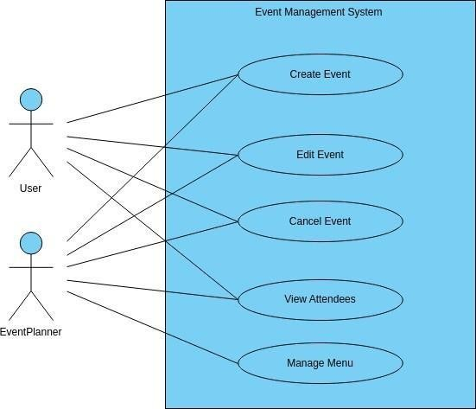

System design is the most creative and challenging. The System Design Document describes the system requirements, operating environment, system and subsystem architecture, files and database design, input formats, output layouts, human-machine interfaces, detailed design, processing logic, and external interfaces.

## GENERAL OVERVIEW

**Fig 4.1 GENERAL OVERVIEW**

## Data Flow Diagram

Data flow diagram is graphical tool which is used to describe and analyze the movement of data through a system. They focus on the data flowing into the system, between processes and in & out of data stores. DFD is a graphical technique that detects information flow and transformation that are applied as data move from input and output.

DFD is a central tool and the basis from which other components are developed. DFD provides mechanism for a final modeling as well as information flow modeling. DFD has very simple notation which are easily understood by the users & those who involved in the system.

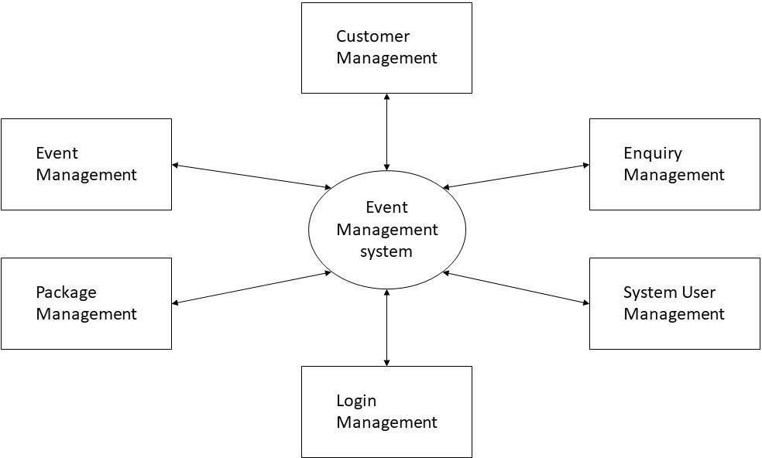

### Characteristics of DFD

* + - DFDs are commonly used during problem analysis.
    - DFDs are quite general and are not limited to problem analysis for software requirements specification.
    - DFDs are very useful in understanding a system and can be effectively used during analysis.
    - It views a system as a function that transforms the inputs into desired outputs.

The DFD aims to capture the transformations that take place within a system to the input data so that eventually the output data is produced.

### Fig 4.2.1 Zero Level DFD Diagram

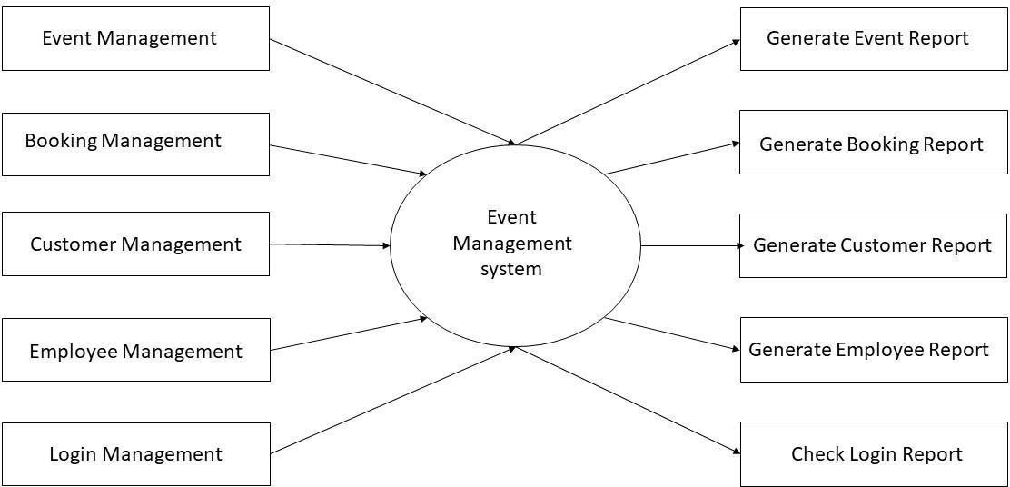

**Fig 4.2.2 First Level DFD Diagram**

### ER Diagram

An Entity-Relationship (ER) diagram is a visual representation of the entities (objects or concepts) within a system or domain and the relationships between them. It is a popular modelling technique used in database design to define the structure and relationships of data.

### Components of an ER diagram:

**Entities:** Entities represent the objects or concepts in the system or domain being modelled. They are typically represented as rectangles with the entity name written inside.

Attributes: Attributes describe the properties or characteristics of an entity. They provide additional details about the entity. Attributes are depicted as ovals connected to their respective entity.

**Relationships:** Relationships represent the associations or connections between entities. They describe how entities are related to each other. Relationships are represented by diamond- shaped symbols connected to the related entities.

Cardinality: Cardinality specifies the number of occurrences of one entity that can be associated with the other entity in a relationship. It can be one-to-one, one-to-many, many-to- one, or many to-many.

**Relationship Attributes:** Relationship attributes are properties or characteristics specific to the relationship between entities. They are depicted as ovals connected to the relationship diamond. Primary Key: A primary key is a unique identifier of an entity. It is used to uniquely identify each instance of the entity. In an ER diagram, the primary key is underlined or highlighted in some way.

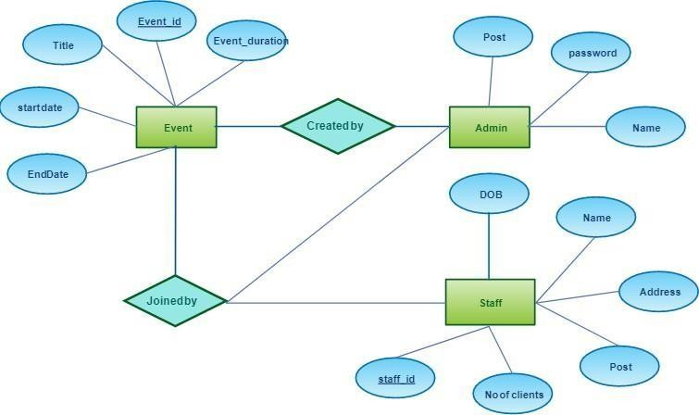

**Foreign Key:** A foreign key is a reference to the primary key of another entity. It is used to establish a relationship between two entities. In an ER diagram, a foreign key is typically depicted as a dashed line connecting the entities involved in the relationship.

**Components of ERD: -**

1. Entity
2. Attributes
3. Relationship

**Fig 4.3 ER Diagram**

### SEQUENCE DIAGRAM

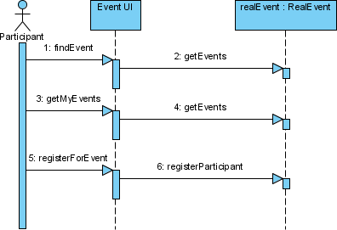

The sequence diagram represents the flow of messages in the system and is also termed as an event diagram. It helps in envisioning several dynamic scenarios. It portrays the communication between any two lifelines as a time-ordered sequence of events, such that these lifelines took part at the run time. In UML, the lifeline is represented by a vertical bar, whereas the message flow is represented by a vertical dotted line that extends across the bottom of the page. It incorporates the iterations as well as branching.

### Purpose of a Sequence Diagram

* + - To model high-level interaction among active objects within a system.
    - To model interaction among objects inside a collaboration realizing a use case. It either models generic interactions or some certain instances of interaction

### Fig 4.4 Sequence Diagram

* 1. **ACTIVITY DIAGRAM**

Activity diagram is basically a flowchart to represent the flow from one activity to another activity. The activity can be described as an operation of the system. The control flow is drawn from one operation to another. This flow can be sequential, branched, or concurrent. Activity diagrams deal with all type of flow control by using different elements such as fork, join, etc.

### Database Tables

Use data tables to show detailed information from a source. Similar to lists, the data tables show data in rows and columns. However, unlike in lists, the data is rendered on the browser side, and not on the server side.

Each column shows all the values for a data item in the database, or a calculation that is based on data items in the database.

You can group and summarize data in data table columns, expand and collapse rows, apply filters to columns, and add custom indicators instead of numbers in measure columns.

### Database Tables

|  |  |  |
| --- | --- | --- |
| **audience** | | |
| **Field** | **Type** | **Constraints** |
| id | int | primary key |
| name | text | NOT NULL |
| contact | varchar(50) | NOT NULL |
| email | varchar(100) | NOT NULL |
| address | text | NOT NULL |
| event_id | int | NOT NULL |
| payment_status | tinyint(1) | NOT NULL |
| attendance_status | tinyint(1) | NOT NULL |
| status | tinyint(1) | NOT NULL |
| date_created | datetime | NOT NULL |

|  |  |  |
| --- | --- | --- |
| **events** | | |
| **Field** | **Type** | **Constraints** |
| id | int | primary key |
| venue_id | int NOT NULL | NOT NULL |
| event | text NOT NULL | NOT NULL |
| description | text NOT NULL | NOT NULL |
| schedule | datetime NOT NULL | NOT NULL |
| type | tinyint(1) NOT NULL | NOT NULL |
| audience_capacity | int NOT NULL | NOT NULL |
| payment_type | tinyint(1) NOT NULL | NOT NULL |
| amount | double NOT NULL | NOT NULL |
| banner | text NOT NULL | NOT NULL |
| date_created | datetime NOT NULL | NOT NULL |

|  |  |  |  |  |  |  |  |
| --- | --- | --- | --- | --- | --- | --- | --- |
| **system_settings** | | | | **users** | | | |
|  |  |  |  |
| **Field** | **Type** | **Constraints** | | **Field** | **Type** | **Constraints** |
| id | int | foreign key |
| id | int | foreign key | |
| name | text | NOT NULL |
| name | text | NOT | NULL |
|  |  | username | varchar(200) | NOT NULL |
| email | varchar(200) | NOT | NULL |
| contact | varchar(20) | NOT | NULL | password | text | NOT NULL |
| cover_img | File | NOT | NULL | type | tinyint(1) | NOT NULL |
| about_content | text | NOT | NULL |  |  |  |

|  |  |  |
| --- | --- | --- |
| **venue** | | |
| **Field** | **Type** | **Constraints** |
| id | int | foreign key |
| venue | text | NOT NULL |
| address | text | NOT NULL |
| description | text | NOT NULL |
| rate | float | NOT NULL |

|  |  |  |
| --- | --- | --- |
| **venue_booking** | | |
| **Field** | **Type** | Constraints |
| id | int | Foreign Key |
| name | text | NOT NULL |
| address | text | NOT NULL |
| email | varchar(100) | NOT NULL |
| contact | varchar(100) | NOT NULL |
| venue_id | int NOT NULL | NOT NULL |
| duration | varchar(100) | NOT NULL |
| datetime | datetime | NOT NULL |
| status | tinyint(1) | NOT NULL |

# CHAPTER 5: TESTING AND IMPLEMENTATION

## UNIT TESTING

### Introduction

In computer programming, unit testing is a software testing method by which individual units of source code, sets of one or more computer program modules together with associated control data, usage procedures, and operating procedures, are tested to determine whether they are fit for use. Intuitively, one can view a unit as the smallest testable part of an application. In procedural programming, a unit could be an entire module, but it is more commonly an individual function or procedure.

In object-oriented programming, a unit is often an entire interface, such as a class, but could be an individual method. Unit tests are short code fragments created by programmers or occasionally by white box testers during the development process. It forms the basis for component testing. Ideally, each test case is independent from the others. Substitutes such as method stubs, mock objects, fakes, and test harnesses can be used to assist testing a module in isolation. Unit tests are typically written and run by software developers to ensure that code meets its design and behaves as intended.

### Benefits

The goal of unit testing is to isolate each part of the program and show that the individual parts are correct. A unit test provides a strict, written contract that the piece of code must satisfy. As a result, it affords several benefits.

Find problems early: Unit testing finds problems early in the development cycle. In test- driven development (TDD), which is frequently used in both extreme programming and scrum, unit tests are created before the code itself is written. When the tests pass, that code is considered complete. The same unit tests are run against that function frequently as the larger code base is developed either as the code is changed or via an automated process with the build. If the unit tests fail, it is considered to be a bug either in the changed code or the tests themselves. The unit tests then allow the location of the fault or failure to be easily traced. Since the unit tests alert the development team of the problem before handing the code off to testers or clients, it is still early in the development process.

**Facilitates Change**: Unit testing allows the programmer to refactor code or upgrade system libraries at a later date, and make sure the module still works correctly (e.g., in regression testing). The procedure is to write test cases for all functions and methods so that whenever a change causes a fault, it can be quickly identified. Unit tests detect changes which may break a design contract.

**Simplifies Integration:** Unit testing may reduce uncertainty in the units themselves and can be used in a bottom-up testing style approach. By testing the parts of a program first and then testing the sum of its parts, integration testing becomes much easier.

**Documentation:** Unit testing provides a sort of living documentation of the system. Developers looking to learn what functionality is provided by a unit, and how to use it, can look at the unit tests to gain a basic understanding of the unit's interface (API). Unit test cases embody characteristics that are critical to the success of the unit. These characteristics can indicate appropriate/inappropriate use of a unit as well as negative behaviors that are to be trapped by the unit.

## INTEGRATION TESTING

Integration testing (sometimes called integration and testing, abbreviated I&T) is the phase in software testing in which individual software modules are combined and tested as a group. It occurs after unit testing and before validation testing. Integration testing takes as its input modules that have been unit tested, groups them in larger aggregates, applies tests defined in an integration test plan to those aggregates, and delivers as its output the integrated system ready for system testing.

### Purpose

The purpose of integration testing is to verify functional, performance, and reliability requirements placed on major design items. These "design items”, i.e., assemblages (or groups of units), are exercised through their interfaces using black-box testing, success and error cases being simulated via appropriate parameter and data inputs. Simulated usage of shared data areas and inter-process communication is tested and individual subsystems are exercised through their input interface.

Test cases are constructed to test whether all the components within assemblages interact correctly, for example across procedure calls or process activations, and this is done after testing individual modules, i.e., unit testing.

The overall idea is a "building block" approach, in which verified assemblages are added to verified base which is then used to support the integration testing of further assemble. Software integration

testing is performed according to the software development life cycle (SDLC) after module and functional tests.

The cross- dependencies for software integration testing are schedule for integration testing, strategy and selection of the tools used for integration, define the complexity of the software and software architecture, reusability of modules and life cycle and versioning management. Some different types of integration testing are big-bang, top- down, and bottom-up, mixed (sandwich) and risky-hardest. Other Integration Patterns are collaboration integration, backbone integration, layer integration, client-server integration, distributed services integration and high-frequency integration.

### Big Bang

In the big-bang approach, most of the developed modules are coupled together to form a complete software system or major part of the system and then used for integration testing. This method is very effective for saving time in the integration testing process. However, if the test cases and their results are not recorded properly, the entire integration process will be more complicated and may prevent the testing team from achieving the goal of integration testing. A type of big-bang integration testing is called "usage model testing" which can be used in both software and hardware integration testing. The basis behind this type of integration testing is to run user-like workloads in integrated user-like environments. In doing the testing in this manner, the environment is proofed, while the individual components are proofed indirectly through their use. Usage Model testing takes an optimistic approach to testing because it expects to have few problems with the individual components. The strategy relies heavily on the component developers to do the isolated unit testing for their product. The goal of the strategy is to avoid redoing the testing done by the developers, and instead flesh-out problems caused by the interaction of the components in the environment.

### Top-down and Bottom-up

Bottom-up testing is an approach to integrated testing where the lowest level components are tested first, then used to facilitate the testing of higher-level components. The process is repeated until the component at the top of the hierarchy is tested. All the bottom or low- level modules, procedures or functions are integrated and then tested. After the integration testing of lower-level integrated modules, the next level of modules will be formed and can be used for integration testing. This approach is helpful only when all or most of the modules of the same development level are ready. This method also helps to determine the levels of software developed and makes it easier to report

testing progress in the form of a percentage. Top- down testing is an approach to integrated testing where the top integrated modules are tested, and the branch of the module is tested step by step until the end of the related module. Sandwich testing is an approach to combine top-down testing with bottom up testing.

## SOFTWARE VERIFICATION AND VALIDATION

### Introduction

In software project management, software testing, and software engineering, verification and validation (V&V) is the process of checking that a software system meets specifications and that it fulfills its intended purpose. It may also be referred to as software quality control. It is normally the responsibility of software testers as part of the software development lifecycle. Validation checks that the product design satisfies or fits the intended use (high-level checking), i.e., the software meets the user requirements. This is done through dynamic testing and other forms of review. Verification and validation are not the same thing, although they are often confused.

Boehm succinctly expressed the difference between

### Validation

Are we building the right product? Verification: Are we building the product, right? According to the Capability Maturity Model (CMMI-SW v1.1)

### Software Verification

The process of evaluating software to determine whether the products of a given development phase satisfy the conditions imposed at the start of that phase.

### Software Validation

The process of evaluating software during or at the end of the development process to determine whether it satisfies specified requirements. In other words, software verification is ensuring that the product has been built according to the requirements and design specifications, while software validation ensures that the product meets the user's needs, and that the specifications were correct in the first place. Software verification ensures that "you built it right". Software validation ensures

that "you built the right thing". Software validation confirms that the product, as provided, will fulfill its intended use.

### Classification of Methods

In mission-critical software systems, where flawless performance is absolutely necessary, formal methods may be used to ensure the correct operation of a system. However, often for non-mission- critical software systems, formal methods prove to be very costly, and an alternative method of software V&V must be sought out. In such cases, syntactic methods are often used.

## SYSTEM IMPLEMENTATION

In this Section we will do Analysis of Technologies to use for implementing the project.

### FRONT END HTML

HTML stands for Hypertext Markup Language. It is a language that is used to create web pages and web applications. HTML uses tags and elements to define the structure and content of a web page. HTML is one of the core technologies of the World Wide Web, along with CSS and JavaScript.

Some of the features of HTML are:

* **User Friendly & Simple**: HTML is easy to learn and use. It has a clear and simple syntax that is based on tags and attributes. HTML tags are predefined and have specific meanings and functions. HTML also allows users to embed other media types, such as images, audio, video, etc., into web pages.
* **Semantic Structure**: HTML5, the latest version of HTML, introduces many new elements that provide semantic meaning to the web page. Semantic elements describe the content and purpose of different parts of a web page,

### CSS

Cascading Style Sheets or css While HTML is used to define the structure and semantics of your content, CSS is used to style it and lay it out. For example, you can use CSS to alter the font, color, size, and spacing of your content, split it into multiple columns, or add animations and other decorative features.

s we have mentioned before, CSS is a language for specifying how documents are presented to users how they are styled, laid out, etc.

A **document** is usually a text file structured using a markup language HTML is the most common markup language, but you may also come across other markup languages such as SVG or XML. **Presenting** a document to a user means converting it into a form usable by your audience. Browser, like Firefox, Chrome, or Edge, are designed to present documents visually, for example, on a computer screen, projector, or printer.

### JavaScript

JavaScript (JS) is a lightweight interpreted (or just-in-time compiled) programming language with first-class functions. While it is most well-known as the scripting language for Web pages, many non- browser environments also use it, such as Node.js, Apache Couch DB and Adobe Acrobat. JavaScript is a prototype-based, multi-paradigm, single-threaded, dynamic language, supporting object-oriented, imperative, and declarative (e.g. functional programming) styles.

JavaScript's dynamic capabilities include runtime object construction, variable parameter lists, function variables, dynamic script creation (via eval), object introspection (via for...in and Object utilities), and source-code recovery (JavaScript functions store their source text and can be retrieved through

This section is dedicated to the JavaScript language itself, and not the parts that are specific to Web pages or other host environments. For information about APIs that are specific to Web pages, please see Web APIs and DOM.

### BACK END

**PHP**

PHP is one of the widely used open-source general-purpose scripting languages for backend Development. Apart from this, let’s see why we should learn it.

* **Easy to Learn:** It is easier to learn for anyone who has come across any programming language for the first time.
* **Free of Cost:** Since it is an open-source language, therefore developers are allowed to use its components and all methods for free.
* **Flexible:** Since It is a dynamically typed language, therefore there are no hard rules on how to build features using it.
* **Supports nearly all databases:** It supports all the widely used databases, including MySQL, ODBC, SQLite etc.
* **Secured:** It has multiple security levels and provides us with a secure platform for developing websites as it has multiple security levels.
* **Huge Community Support:** It is loved and used by a huge number of developers. The developers share their knowledge with other people in the community who want to know about it.

### MYSQL

MySQL is one of the most recognizable technologies in the modern big data ecosystem. Often called the most popular database and currently enjoying widespread, effective use regardless of industry, it’s clear that anyone involved with enterprise data or general IT should at least aim for a basic familiarity of MySQL.

With MySQL, even those new to relational systems can immediately build fast, powerful, and secure data storage systems. MySQL’s programmatic syntax and interfaces are also perfect gateways into the wide world of other popular query languages and structured data stores.

A database is a structured collection of data. It may be anything from a simple shopping list to a picture gallery or a place to hold the vast amounts of information in a corporate network. In particular, a relational database is a digital store collecting data and organizing it according to the relational model. In this model, tables consist of rows and columns, and relationships between data elements all follow a strict logical structure. An RDBMS is simply the set of software tools used to actually implement, manage, and query such a database.

## 5.4 SYSTEM MAINTENANCE

Similarly, your e-commerce website is bound to slow down with the time when it accumulates more data. Your website needs to be fixed for a fast-loading speed that can be done by updating plugins of your website, updating the version of CMS, WordPress maintenance, optimizing website images, and installing cache plugin on your website. Users are likely to abandon a slow loading website and go elsewhere if the pages take too long to load.

Ensure that all of your webpages have updated text, images, and content that can be done using Google Analytics to understand both your site and its audience. With analytics, you can track your site’s elements that work well and those that don’t. You can also track visitor behavior on your website and lead generation.

### Maintain a Secure Backup Data

The backup of your site data is the most crucial part of ecommerce security and website maintenance. You will need to have backups of data stored in files or the cloud and restored when needed.

A backup helps the web designers to combat against disruption of your website. A backup of data is needed when some of your website’s critical files get corrupted or have some errors that could damage your website and make it extremely hard to fix. For your site maintenance, a backup copy of the latest version of your website data can save you and make your website working again. If you don’t have a backup of data and your website is hacked, you’d need to create it from scratch. Similarly, software updates are ever-changing and require regular updates for programs. Your website maintenance needs to stay on top of software updates to avoid data theft issues.

### Maintenance of Your Store’s Information

Website Maintenance involves updating the information present in the ecommerce store. It is related to your product information, price changes, product images, discounts, offers, etc. Keeping up the maintenance of your storefront also ensures a great user experience so that the audience will only get the products from the latest trends. Maintaining product information on your store helps attract new customers and let customers know what’s newly released. It’s also essential to update what products are in stock, low on stock, or out of stock. Not providing your customers with the updated information disappointments them and pushes them to look for other websites.

Not updating product images or descriptions can be seen as false advertising. Your marketing team should inform the customers by sending out emails and through social media updates. Remember, the cost of fixing online issues will be greater than the affordable website maintenance costs.

### Need for Maintenance

Software Maintenance is needed for: -

* Correct errors
* Change in user requirement with time
* Changing hardware/software requirements
* To improve system efficiency
* To optimize the code to run faster
* To modify the components

# CHAPTER 6: CONCLUDING REMARKS

## SCOPE FOR FUTURE DEVELOPMENT

### Hybrid Event Management Structure:

* + Traditional on-ground events are evolving into **hybrid events**. These combine the advantages of physical gatherings with modern technology.
  + Hybrid events allow for global participation, seamless virtual experiences, and enhanced client engagement.

### Risk Appetite:

* + The pandemic taught us that uncertainty is inevitable. Event professionals will take more **calculated risks** and embrace innovation.

### Global Opportunities:

* + Remote work has blurred geographical boundaries. Event professionals can now seek incredible career opportunities **globally**.

### Immersive Virtual and Hybrid Events:

* + Virtual and hybrid events will continue to thrive. These formats offer flexibility, accessibility, and cost-effectiveness.

### Personalized Experiences through AI and Data Analytics:

* + AI-driven personalization will become more prevalent. Customized content, recommendations, and targeted marketing will engage attendees.

### Sustainability and Green Events:

* + Environmental consciousness is growing. Event organizers will focus on reducing waste, energy consumption, and carbon footprint.

### Augmented Reality (AR):

* + AR can transform event experiences. Imagine interactive AR displays, virtual tours, and gamified elements during conferences and exhibitions.

### Gamification:

* + Gamifying events encourages participation, competition, and engagement.

### Enhanced Safety and Security Measures:

* + Post-pandemic, health and safety protocols will remain critical.

## ADVANTAGES

Event management systems (EMS) offer numerous advantages that streamline the planning and execution of events. Here are some key benefits:

* + **Centralized Control**: An EMS provides a single platform to manage all aspects of an event, from registration to analytics, making the process more organized and efficient.
  + **Time Efficiency**: By automating tasks and centralizing data, an EMS saves valuable time that can be used for other critical event planning aspects.
  + **Cost-Effectiveness**: EMS reduces the need for multiple software solutions and manual labor, cutting down on operational costs.
  + **Enhanced Engagement**: Features like networking tools, live polls, and interactive sessions within an EMS can significantly increase attendee engagement.
  + **Data Insights**: An EMS can gather and analyze data on attendee behavior, preferences, and feedback, which is invaluable for improving future events.
  + **Robust Reporting**: With built-in reporting tools, an EMS can provide detailed insights into event performance, helping organizers make data-driven decisions.
  + **Scalability**: EMS platforms can handle events of varying sizes, making them suitable for small meetings to large conferences.
  + **Improved Attendee Experience**: By facilitating smooth check-ins, personalized schedules, and easy access to event information, an EMS enhances the overall attendee experience.
  + **Risk Management**: An EMS can help identify potential risks and provide solutions to mitigate them, ensuring the event runs smoothly.
  + **Sustainability**: Digitalizing event management processes reduces the need for paper, contributing to eco-friendly event practices.

### CONCLUSION

Event management systems (EMS) revolutionize the way events are planned, executed, and analyzed. By centralizing control, saving time, reducing costs, enhancing engagement, and providing valuable data insights, EMS platforms empower event organizers to create successful and memorable experiences. As the industry evolves, embracing technology and sustainability will further amplify the impact of EMS in shaping the future of events.

### Advantages of Event Management Systems (EMS)

* + 1. **Cost Efficiency and Resource Optimization**:
       - EMS significantly reduces costs associated with manual processes, paperwork, and administrative overhead.
       - Efficient resource allocation ensures optimal utilization of budgets and personnel.

### Streamlined Planning and Execution:

* + - * Centralized control allows seamless management of event logistics, schedules, and communication.
      * From registration to post-event analysis, EMS simplifies every stage of event planning.

### Enhanced Attendee Engagement:

* + - * Interactive features within EMS platforms foster engagement.
      * Attendees benefit from personalized experiences, real-time notifications, and networking opportunities.

### Data-Driven Decision Making:

* + - * EMS collects valuable data on attendee behavior, preferences, and feedback.
      * Robust analytics enable organizers to make informed decisions for future events.

### Global Accessibility and Reach:

* + - * Virtual and hybrid events transcend geographical boundaries.
      * Attendees from remote locations can participate, expanding the event’s impact.

### Security and Confidentiality:

* + - * EMS ensures data privacy and secure transactions.
      * Authentication protocols safeguard attendee information.

### Efficient Risk Management:

* + - * Identifying and mitigating risks becomes easier with real-time monitoring.
      * Emergency response plans can be executed swiftly.

### Sustainability and Eco-Friendly Practices:

* + - * Digitalization reduces paper usage and promotes eco-conscious event management.
      * Sustainable practices align with global environmental goals.

### Real-Time Results and Feedback:

* + - * EMS provides instant event metrics, allowing organizers to adapt during the event.
      * Attendee feedback informs continuous improvement.

# CHAPTER 7: REFERENCES

### Books Reference: -

Introducing the MySQL 8 Document Store by Charles Bell Fundamentals of Software Engineering: ERD, DFD, Rajiv Mall. MySQL Connector/Python Revealed by Jasper Weisberg Krogh Ivan Bayross, Sharanam Shah, “HTML, CSS, JavaScript”:

Silber Schatz, North and Sudarshan, “Database System Concept”: Database Connections.

### Website Reference: -

[https://www.tutorialspoint.com](https://www.tutorialspoint.com/) Feasibility Study, https[://www.mongodb.c](http://www.mongodb.com/resources/languages/mern-stack)o[m/resources/languages/mern-stack](http://www.mongodb.com/resources/languages/mern-stack) https:[//www.tutorialspoint.com/](http://www.tutorialspoint.com/JavaScript/index.htm)J[avaScript/index.htm](http://www.tutorialspoint.com/JavaScript/index.htm) https:[//www.w3schools.com/](http://www.w3schools.com/MySQL/DEFAULT.ASP)M[ySQL/DEFAULT.ASP](http://www.w3schools.com/MySQL/DEFAULT.ASP)

# CHAPTER 8: APPENDIX-SCREEN SHOTS

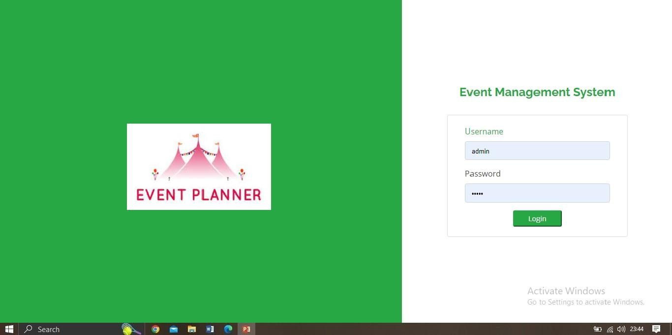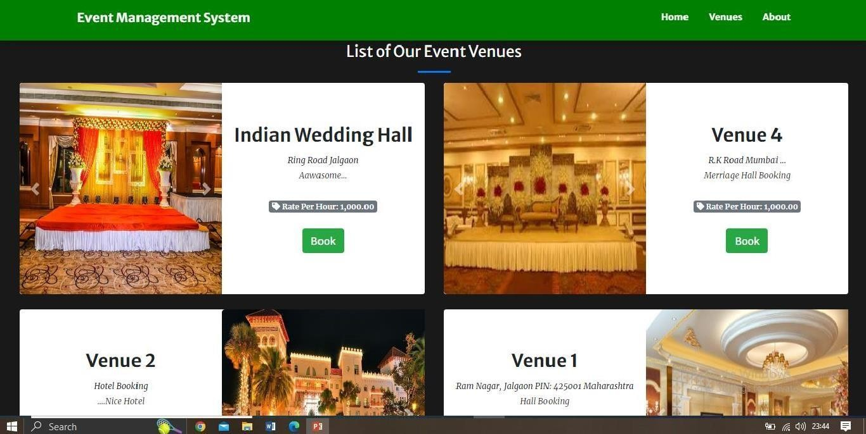

## Input Screens

### Admin Login

**Venues Page**

### Add New Venue

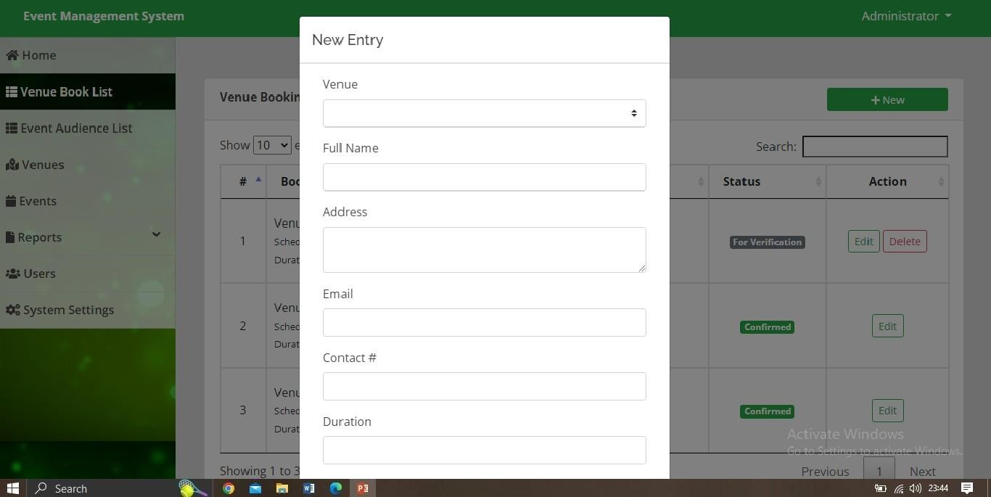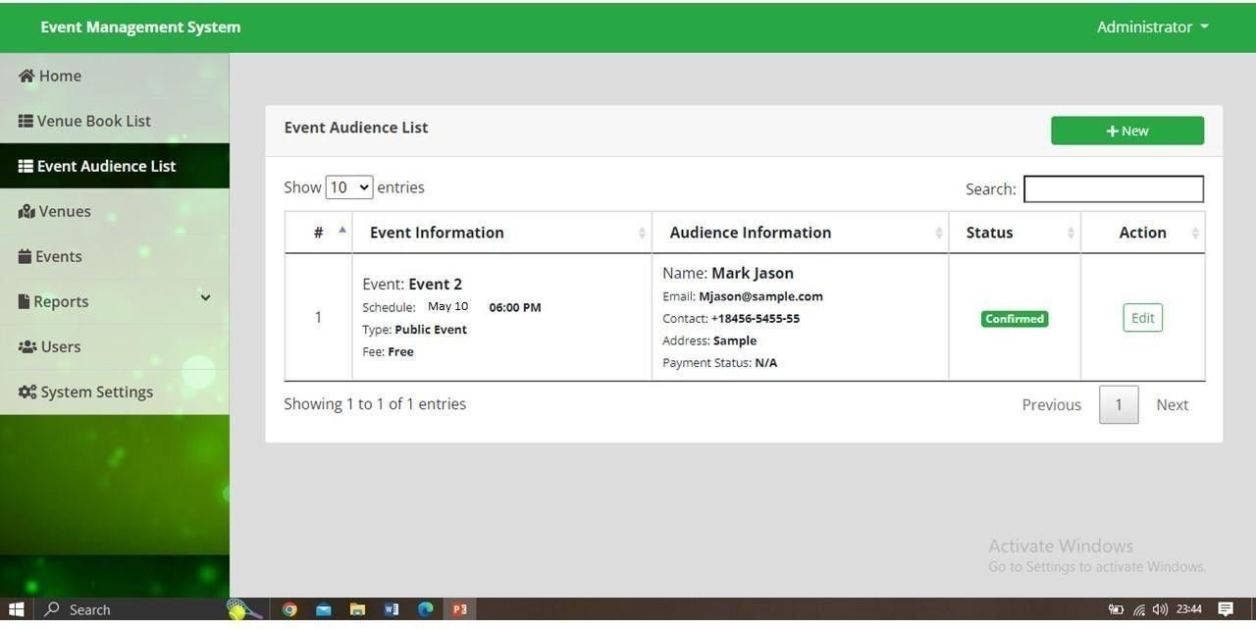

**Event Audience List**

### Setting

